GROW WISE



THESIS SUBMITTED TOWARDS THE PARTIAL FULFILLMENT OF THE REQUIREMENT OF THE UNIVERSITY OF SINDH, FOR THE AWARD OF BACHELOR OF SCIENCE IN SOFTWARE ENGINEERING

SUBMITTED BY
Abdul Kabeer 2K20/SWE/06
Muhammad Bilal Raza 2K20/SWE/61
Mukhtyar Khan 2K20/SWE/74

SUPERVISOR
Dr.Mumtaz Qubolio
Assistant Professor
Department of Software Engineering

DEPARTMENT OF SOFTWARE ENGINEERING
FACULTY OF ENGINEERING AND TECHNOLOGY

UNIVERSITY OF SINDH
Session 2023

CERTIFICATE
Grow Wise
A Thesis Submitted By:

Abdul Kabeer 2K20/SWE/06
Muhammad Bilal Raza 2K20/SWE/61
Mukhtyar Khan 2K20/SWE/74

______________________________ | _______________________________
Supervisor’s name and signature | Final Year Projects’ Coordinator
______________________________ | _______________________________
Co-Supervisor’s name and signature | Final Year Projects’ Committee Head
 | _______________________________
Chairman
Department of Software Engineering

ACKNOWLEDGEMENTS
We are thankful to almighty ALLAH, who made it possible this learning journey. We are deeply grateful for the guidance and support we received throughout this project. We recognize the contributions of many individuals who helped us learn and grow.
We first and foremost express our sincere gratitude to our supervisor, Dr. Mumtaz Qubolio.
We are thankful to Dr. Arifa Bhutto for guiding us and introducing us to different people for our project. We would like to appreciate Dr. Sajjad Ali for his time in annotating the images of disease dataset.
We are grateful for our friends whose encouragement and feedback make this project possible. Especially Hassan Samo and Adeel Atta for their feedback and help in development of the project.
Our special appreciation and thanks to our family who always stands by us no matter what happens. Their support and encouragement were such a boost for our capabilities and confidence to undergo this period last but certainly not least.
We also like to thank everyone who direct or indirectly helped us in this project.

ABSTRACT
In response to the challenges posed by climate change on agriculture, this project proposes a multifaceted solution incorporating machine learning, web technologies, and agricultural data. The system encompasses a Disease Identifier achieving 92% accuracy in identifying crop diseases through leaf images, coupled with treatment recommendations. The Crop Recommender, powered by Artificial Neural Networks (ANN), predicts optimal crops with 90% accuracy based on soil and environmental data.
With a focus on assisting farmers in decision-making, the project aims to predict suitable crops, identify diseases, and provide plant information. The scope covers disease identification for 15 plants, crop recommendation for 22 crops, and a plant information search. The incremental model facilitates systematic development.
The technology stack includes HTML for structure, CSS for styling, JavaScript for interactivity, Python for machine learning and backend, Flask as the web framework, Jinja2 for templates, and MySQL as the database. Datasets for disease identification and crop recommendation are diverse, sourced from Kaggle. Machine learning involves Artificial Neural Networks (ANN) for crop prediction and Convolutional Neural Networks (CNN) for disease identification in plant images.
In conclusion, this project addresses critical agricultural challenges, offering a comprehensive support system. It empowers farmers with informed decisions on crop selection, disease management, and plant information provides the information about diverse set of plants. Ongoing efforts include expanding datasets for improved accuracy and enhancing the plant information search feature.

CONTENTS:
CERTIFICATE i
ACKNOWLEDGEMENTS ii
ABSTRACT iii
CONTENTS: iv
ABBREVIATION vi
LIST OF FIGURES vii
Chapter 1: Introduction 1
1.1 Background 1
1.2 Aims And objectives 1
1.3 Scope 2
Chapter 2: Literature review 3
2.1 Literature review 3
2.2 Similar projects 3
Chapter 3: Methodology, Requirements, Design 5
3.1 Methodology 5
3.2 Requirements 6
3.3 Design 7
Chapter 4: Tools and Technology 16
4.1 HTML 16
4.2 CSS 16
4.3 Javascript 16
4.4 Python 16
4.5 Flask 17
4.6 Jinja2 17
4.7 MySQL 18
4.8 Dataset 18
4.9 Machine Learning 19
Chapter 5: Implementation 21
5.1 Landing Page 21
5.2 CROP DISEASE IDENTIFICATION PAGE 21
5.3 Crop Recommendation page 23
5.4 Plant information Search page: 24
Chapter 6: Results and Conclusions 25
6.1 Result: 25
6.2 Conclusion: 29
6.3 Future work: 29
References: 30

ABBREVIATION
DL | Deep Learning
DFD | Data Flow Diagram
ERD | Entity Relationship Diagram
ML | Machine Learning
HTML | HyperText Markup Language
CSS | Cascading Style Sheet
JS | JavaScript
WSGI | Web Server Gateway Interface
SQL | Sequential Query Language
AI | Artificial Intelligence
ANN | Artificial Neural Network
NN | Neural Network
CNN | Convolutional Neural Network
FAQ | Frequently Asked Question

LIST OF FIGURES
Figure 3-1: Incremental Model 5
Figure 3-2: Use case diagram 8
Figure 3-3: System architecture diagram 9
Figure 3-4: Disease Identification Sequence Diagram 10
Figure 3-5: Crop Recommender Sequence Diagram 11
Figure 3-6: Plant Information Search Sequence Diagram 12
Figure 3-7: Data flow diagram 13
Figure 3-8: Entity relationship diagram 14
Figure 3-9: Machine learning workflow diagram 15
Figure 5-1: Landing Page 21
Figure 5-2: Disease identification page 22
Figure 5-3: Disease identification upload image 22
Figure 5-4: Disease identification result 23
Figure 5-5: Crop recommender page 23
Figure 5-6: Crop recommender result 24
Figure 5-7: Plant information search page 24
Figure 6-1: Disease identification (Cotton) accuracy 25
Figure 6-2: Disease identification (Banana) accuracy 26
Figure 6-3: Disease identification (Mango) accuracy 26
Figure 6-4: Disease identification (Wheat) accuracy 27
Figure 6-5: Disease identification (Pepper) accuracy 27
Figure 6-6: Crop recommender training and validation loss 28
Figure 6-7: Crop recommender classification report 28

Introduction

Background
In the age of climate change, even the farmers who possess indigenous knowledge face difficulties in making judicious decisions on crop health monitoring that leads to the failure of the crop which in turn results in the decline of crop production. Another reason for the decline in crop production can be the selection of unsuitable crops for cultivation and the inability of identifying the visible effect of the disease in a plant. To detect the disease manually in plants is a critical job in the farming field, as ailments in plants are very regular. Thus, there comes a need of a model that can predict the disease so that farmers can take necessary actions, it is important to be able to predict and forecast the performance of the crop for all kinds of environmental conditions and to suggest essential crops according to the climate condition [1].

Aims And objectives

Aims
This project aims to assist users in making informed decisions by predicting the most suitable crops to sow on the fields, identifying crop diseases and suggesting effective treatments and searching for basic information about various plants.

Objectives
- To develop a crop disease identifier that identifies plant diseases through leaf analysis and suggests suitable treatments.
- To develop a crop recommender system that advice farmers on the best crops to sow based on soil test results and environmental conditions.
- To offer a platform to search for information about plants.
- To provide a minimalistic interface to assist the farmers in making informed decisions about their crop selection and disease management, as well as in search for crop-related information.

Scope
The project's primary focus revolves around the creation of a sophisticated agricultural support system with a multifaceted approach. At its core, the system aims to incorporate image recognition technology for the accurate identification and diagnosis of plant diseases. The system not only identifies diseases with precision but also proposes effective treatment options for disease management. Complementing this, crop recommendation mechanism, utilizing soil test results and environmental conditions to suggest the most suitable crops for cultivation. This recommendation system is designed to enhance agricultural practices by providing tailored suggestions aligned with specific soil characteristics and environmental factors. Additionally, the project endeavours to establish a user-friendly platform offering basic information on various plants. This platform serves as a valuable resource. However, it's important to acknowledge certain limitations within the project. the disease identification component covers 15 plants with a finite dataset of diseases for each plant. Similarly, the crop recommendation system relies on a dataset encompassing information for 22 crops, and its accuracy could benefit from a more extensive crop database. Expanding these datasets holds the potential to enhance the system's capabilities further. It's crucial to recognize that the accuracy of recommendations and disease identifications is dependent on the quality of input data, and ongoing efforts are directed towards ensuring and improving data quality. Lastly, the plant information search provides restricted information of limited number of plants data, it can be further extended.

Literature review

Literature review
Significant advancements have been made in the agricultural sector. For instance, researchers have tried to develop models for identifying diseases and the best crops to sow based on soil conditions [1]. Another study has tried to develop a web application for disease detection [2] but according to study Agricultural environments are highly variable, and models trained on data from one region or crop may not perform well in others. Therefore, domain adaptation is a crucial challenge in DL for agriculture, where models must adapt to new environments and crops and DL models are highly sensitive to changes in environmental conditions that can affect their performance. It is essential to design DL models that are robust to changes in environmental conditions such as weather, soil, and lighting [3]. Furthermore, according to a study model are trained for detecting plant diseases but still lack a good amount of image dataset for enhancement in the model accuracy [4].

Similar projects

Bakhabar Kissan
BaKhabar Kissan, an AgriTech company based in Pakistan, is dedicated to aiding farmers in making decisions driven by data. The company adopts a holistic strategy to tackle issues related to both production and the agricultural value chain. Their services encompass a wide range, including advice on crops and livestock, weather forecasts, market rates, and guidance based on remote sensing. The platform also serves as a bridge connecting farmers with consumers and businesses, thereby facilitating the promotion of their products. BaKhabar Kissan tailors the journey of each farmer on the platform according to their location, crops, and other factors. Despite operating as an e-commerce platform committed to enhancing farmers’ lives, BaKhabar Kisan provides only limited crop information for product promotion [5].

aari.punjab.gov.pk
The Ayub Agricultural Research Institute (AARI) plays a pivotal role in driving growth in key crops within the region. Its mission is cantered on the development of innovative crop varieties and technologies aimed at enhancing food safety, security, and the sustainable production of goods for export. In addition to this, AARI is committed to adding value and conserving natural resources. While it offers valuable information about crops, it’s noteworthy that their focus is primarily on specific crops. This focus allows them to provide detailed and specialized knowledge, but it also limits the breadth of their information [6].

agri.sindh.gov.pk
A key part of their work involves collecting vital agricultural statistics and keeping growers informed about urgent issues such as insect pest outbreaks and weather forecasts. This proactive approach helps farmers stay ahead of potential challenges. The department is particularly dedicated to the development of high-yielding crop varieties that are resistant to insects, pests, and diseases. This focus on resilience benefits both major and minor crops, contributing to a more robust agricultural sector [7].

Cropedia: A crop encyclopedia (last year’s project)
Cropedia, a crop encyclopedia, serves as a valuable web tool for disseminating agricultural information. It provides insights into the requirements, seeding, and harvesting processes for specific crops. Offering additional features like crop prediction based on soil potential and crop annotation, Cropedia aims to connect farmers with selected specialists, particularly botanists, who can provide guidance on optimal crop care for maximum production.
Despite its utility, Cropedia does exhibit some limitations. The platform offers information on a limited number of plants without a comprehensive search bar, hindering users from accessing data on a wider range of crops. Moreover, their crop recommendation model is trained on a relatively small dataset, potentially limiting the accuracy and diversity of recommendations. Additionally, the process of connecting farmers with botanists may prove time-consuming, impacting the efficiency of support services [8].

Methodology, Requirements, Design

Methodology

Incremental model:
The incremental model is a software development methodology that can be used to build large and complex systems. It's based on the idea of adding new features, or "increments," to an existing system instead of building the entire thing from scratch at once. Incremental model has two types (1) staged delivery incremental model, in which just one section of the project is built at a time. This allows for the product or service to be developed and delivered in stages, with each stage building on the previous one and (2) parallel delivery incremental model, in which different subsystems are built concurrently. It can reduce the time required for the development process as long as there are enough resources available [9]. Given the project’s nature and requirement, the incremental model has been strategically employed to facilitate systematic development for our agricultural support system.
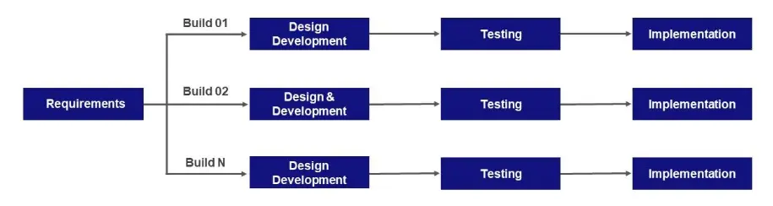

Figure 3-1: Incremental Model

Requirements
Requirements analysis is a very critical process that enables the success of a system or software project to be assessed. Requirements are generally split into two types: Functional and Non-functional requirements. Functional Requirements are the requirements that the end user specifically demands as basic facilities that the system should offer. All these functionalities need to be necessarily incorporated into the system as a part of the contract. Non-Functional Requirements are the quality constraints that the system must satisfy according to the project contract. The priority or extent to which these factors are implemented varies from one project to another. They are also called non-behavioural requirements. They deal with issues like Portability, Security, Maintainability [10].
Functional and Non-Functional requirements identified for this project are:

Functional Requirements

Disease Identification
- Users can identify diseases affecting their crops by uploading images of defected leaves.
- The application will diagnose the disease and provide management directions for the identified issue.

Crop Recommender
- Users can receive crop recommendations based on provided data.
- Inputting current soil data will generate recommendations for the best crop to sow.
- Additional information about the recommended crop, including scientific name, family name, and planting requirements, will be displayed.

Plant Information Search
- Users can search for plant information by entering the plant's name.
- Essential information about the plant, such as scientific name, family name, planting requirements, and common diseases, will be provided.

Non-Functional Requirements

Accuracy
The system will ensure high accuracy in providing plants' information, disease identification, and crop recommendations.

Reliability
The system will be reliable and capable of handling many requests without experiencing downtime.

Availability
The system will maintain high availability, ensuring it is operational for most of the time.

Performance
The system will provide services with efficient speed, ensuring a responsive and timely user experience.

Design
Software design is a phase that comes after the requirement analysis of the software. In this phase, the requirements of the software are represented in a form that can easily be implemented through any coding language by the software developers. The software design is like a blueprint of the software. After the design phase, the software undergoes the coding and implementation phase [11]. Following are the identified diagrams for our project:

Use Case
A use case diagram can summarize the details of system's users (also known as actors) and their interactions with the system. To build one, you'll use a set of specialized symbols and connectors [12].

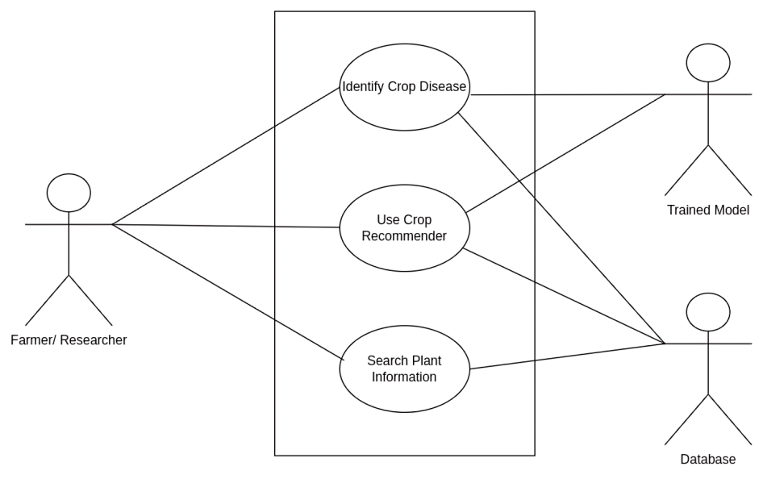
Figure 3-2: Use case diagram

System Architecture
The architecture of a system reflects how the system is used and how it interacts with other systems and the outside world. It describes the interconnection of all the system’s components and the data link between them. The architecture of a system reflects the way it is thought about in terms of its structure, functions, and relationships [13].
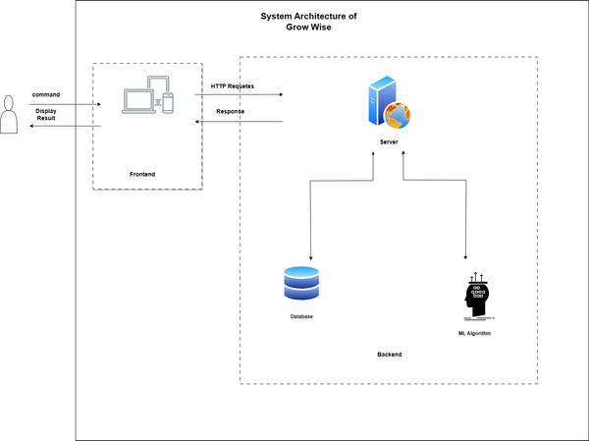
Figure 3-3: System architecture diagram

Sequence diagram
Sequence Diagram is an interaction diagrams that detail how operations are carried out. They capture the interaction between objects in the context of a collaboration. Sequence Diagrams are time focus, and they show the order of the interaction visually by using the vertical axis of the diagram to represent time what messages are sent and when [14].
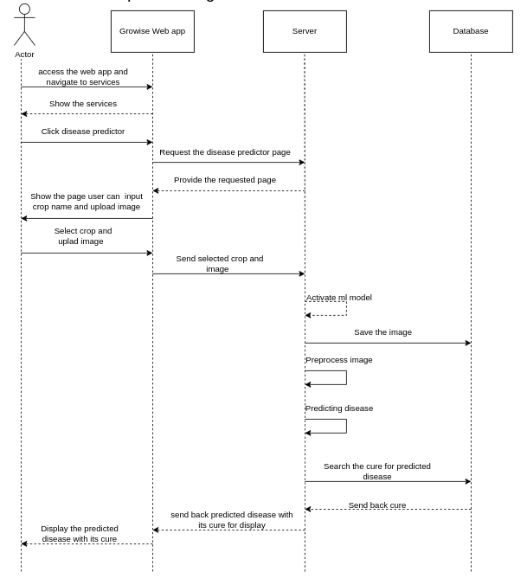
Figure 3-4: Disease Identification Sequence Diagram

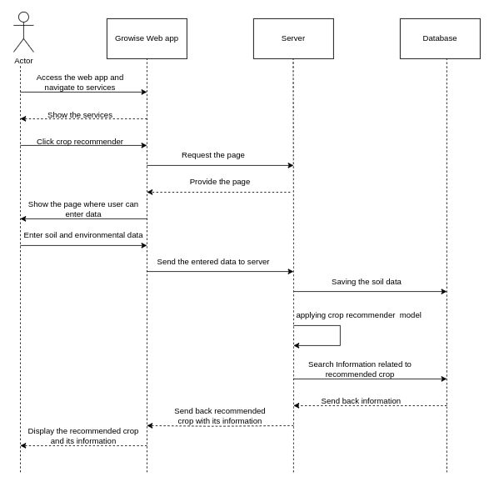
Figure 3-5: Crop Recommender Sequence Diagram

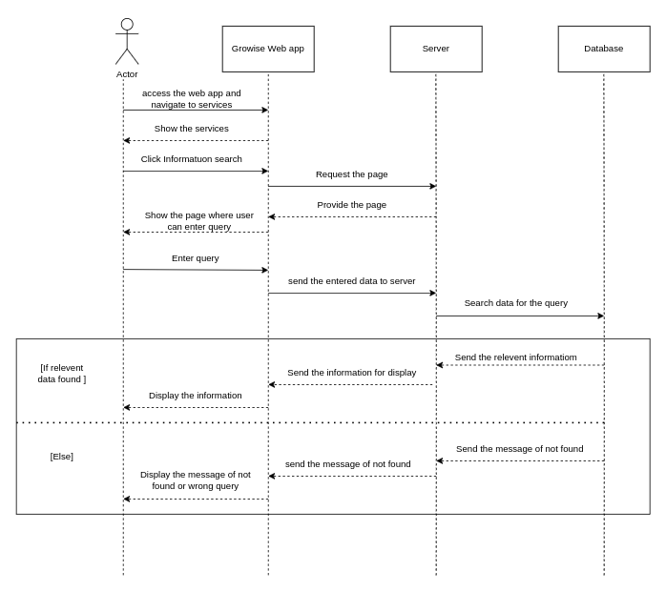
Figure 3-6: Plant Information Search Sequence Diagram

Data Flow Diagram (DFD)
A data flow diagram (DFD) maps out the flow of information for any process or system. It uses defined symbols like rectangles, circles and arrows, plus short text labels, to show data inputs, outputs, storage points and the routes between each destination [15].

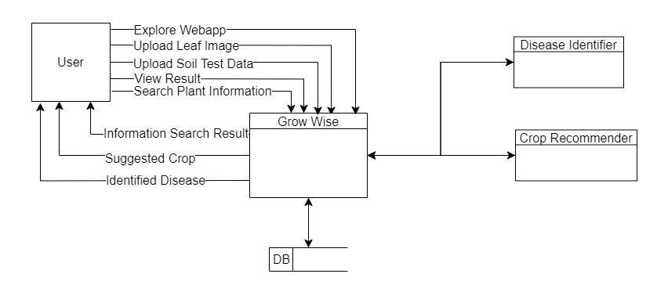
Figure 3-7: Data flow diagram

Entity Relation Diagram (ERD)
An Entity Relationship (ER) Diagram is a type of flowchart that illustrates how “entities” such as people, objects or concepts relate to each other within a system. ER Diagrams are most often used to design or debug relational databases in the fields of software engineering, business information systems, education and research. Also known as ERDs or ER Models, they use a defined set of symbols such as rectangles, diamonds, ovals and connecting lines to depict the interconnectedness of entities, relationships and their attributes. They mirror grammatical structure, with entities as nouns and relationships as verbs. [16].
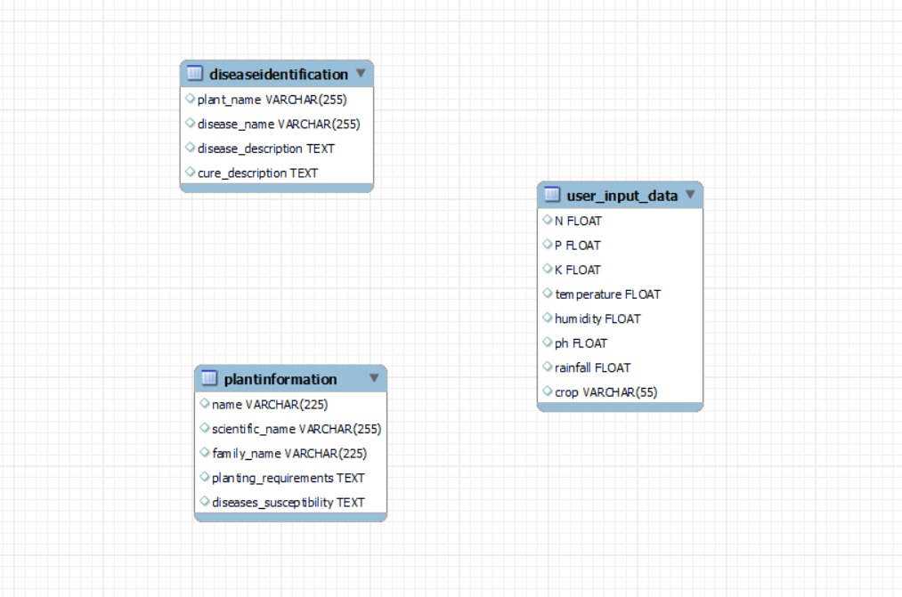
Figure 3-8: Entity relationship diagram

Machine Learning workflow:
The machine learning workflow is a sequential process encompassing data collection, pre-processing, and feature engineering. Model selection and training follow, culminating in evaluation, and testing for real-world applicability. The final steps involve model deployment and ongoing monitoring, ensuring continuous refinement and adaptation to changing data dynamics.
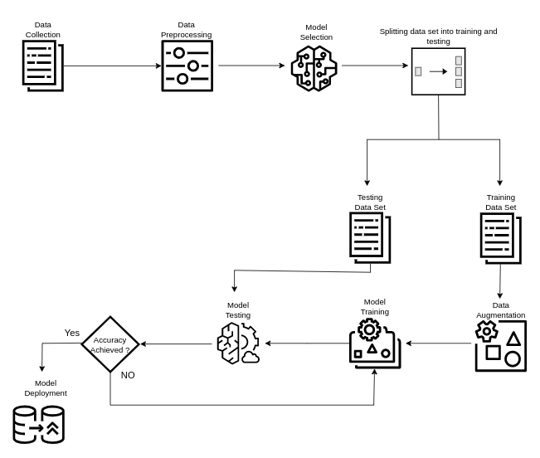
Figure 3-9: Machine learning workflow diagram

Tools and Technology

HTML
HTML (Hypertext Markup Language) is the most basic building block of the Web. It defines the meaning and structure of web content. [17]. HTML is instrumental in defining and structuring the webpages. In our project, HTML played a pivotal role in shaping the UI by organizing the content element. Various HTML tags, including ‘<head>’, ‘<body>’, ‘<p>’, ‘<div>’, and others, were strategically employed to create a coherent layout.

CSS
CSS is a style sheet language. CSS is what you use to selectively style HTML elements [18]. CSS played pivotal role in enhancing the visual aesthetic and user experience of our project. We strategically utilize CSS to tailor the appearance of our project. Selectors were employed to target specific HTML elements, allowing us to define their presentation across diverse device sizes. Media queries were seamlessly integrated to ensure a responsive design, dynamically adjusting the layout based on user’s device.

Javascript
JavaScript (JS) is a lightweight interpreted (or just-in-time compiled) programming language with first-class functions. While it is most well-known as the scripting language for Web pages, many non-browser environments also use it, such as Node.js, Apache CouchDB and Adobe Acrobat. JavaScript is a prototype-based, multi-paradigm, single-threaded, dynamic language, supporting object-oriented, imperative, and declarative (e.g. functional programming) styles. [19]. In our project, JavaScript utilizes for enhancing user engagement and functionality. Leveraging its capabilities, we employed JavaScript to implement various interactive features, such as form validation, client-side data manipulation.

Python
Python is a high-level, general-purpose programming language. Its design philosophy emphasizes code readability with the use of significant indentation. Python is dynamically typed, and garbage collected. It supports multiple programming paradigms, including structured (particularly procedural), object-oriented and functional programming. It is often described as a "batteries included" language due to its comprehensive standard library [20].
In our project, Python takes centre stage, serving dual roles. Firstly, it plays a pivotal role in the training of machine learning models, leveraging its rich ecosystem of libraries. Secondly, Python serves as the backend programming language, seamlessly handling server-side logic, processing requests, executing machine learning processes, and facilitating interactions within the system.

Flask
Flask is a lightweight WSGI web application framework. It is designed to make getting started quick and easy, with the ability to scale up to complex applications. It began as a simple wrapper around Werkzeug and Jinja and has become one of the most popular Python web application frameworks.
Flask offers suggestions but doesn’t enforce any dependencies or project layout. It is up to the developer to choose the tools and libraries they want to use. There are many extensions provided by the community that make adding new functionality easy [21].
In our project, Flask serves as the backbone, seamlessly connecting the backend logic with the frontend. Its flexibility allows developers to choose tools and libraries based on project requirements.

Jinja2
Jinja2 is a full-featured template engine for Python. It has full Unicode support, an optional integrated sandboxed execution environment, widely used. Jinja2 is one of the most used template engines for Python. It is inspired by Django's templating system but extends it with an expressive language that gives template authors a more powerful set of tools. On top of that it adds sandboxed execution and optional automatic escaping for applications where security is important.
It is internally based on Unicode and runs on a wide range of Python versions from 2.5 to current versions including Python 3 [22].
In our project, Jinja2 takes centre stage in creating dynamic HTML templates, contributing significantly to the generation of a dynamic user interface. It increases code reusability by constructing the base layout file and enhancing the overall structure and functionality of the website.

MySQL
MySQL, the most popular Open-Source SQL database management system, is developed, distributed, and supported by Oracle Corporation [23].
In our project, MySQL plays a pivotal role as the primary database engine. Leveraging MySQL's capabilities, we organize and store data efficiently in structured tables. The relational nature of MySQL facilitates seamless data retrieval, ensuring the reliability and integrity of information crucial for our crop recommendation, disease identification, and plant information search functionalities. Its open-source nature aligns with our commitment to accessible and scalable solutions, making MySQL an integral component for data management and retrieval in our project.

Dataset

Disease Identifier
The dataset utilized for the Disease Identifier is a culmination of diverse sources to ensure a robust and comprehensive training ground for our model. We adopted a multi-faceted approach, incorporating field-collected data, scraping information from Google Images, and leveraging datasets from Kaggle [24-30].
Specifically, we utilized dataset like cotton plant disease [24], cotton leaf dataset [25], new plant disease dataset [26], Bangladeshi crops disease dataset [27], Soybean leaf data for disease identification [28], Mango leaf disease dataset [29], Rice leaf dataset [30], all obtained from Kaggle. This diverse collection enables our model to recognize diseases across various crops, contributing to the versatility of our Disease Identifier system.

Crop Recommender
For the Crop Recommender, our primary dataset has been sourced from Kaggle [31], a well-known platform for datasets. This dataset contains a comprehensive collection of agricultural data, including soil characteristics, climate conditions. To ensure data integrity and reliability, a rigorous pre-processing and cleaning phase was undertaken. This involved handling missing values, standardizing formats, and removing outliers.
The dataset consists of 2200 entries, each representing a unique combination of soil attributes and environmental conditions. Notably, it covers a diverse range of crops, providing a rich source of information for our recommendation system. The decision to choose this dataset was driven by its size, relevance to our project objectives, and the availability of essential features required for accurate crop recommendations.
This dataset serves as a foundational element in our project, aligning with our goal of delivering precise and context-aware crop recommendations to farmers.

Plant Information Search
This dataset encompasses information such as the plant's scientific name, family name, planting requirements, and susceptibility to diseases. This data was scrapped, from diverse website ensuring a wide coverage of plant information. This dataset serves as the foundation for delivering valuable insights to users seeking plant-related information.

Machine Learning
Machine Learning, often abbreviated as ML, is a subset of Artificial Intelligence (AI) that focuses on the development of computer algorithms that improve automatically through experience and by the use of data. In simpler terms, machine learning enables computers to learn from data and make decisions or predictions without being explicitly programmed to do so. Deep learning, on the other hand, is a subfield of machine learning dealing with algorithms based essentially on multi-layered artificial neural networks (ANN) that are inspired by the structure of the human brain [32].

Artificial Neural Network (ANN)
Artificial neural networks (ANNs, also shortened to neural networks (NNs) or neural nets) are a branch of machine learning models that are built using principles of neuronal organization discovered by connectionism in the biological neural networks constituting animal brains. An ANN is made of connected units or nodes called artificial neurons, which loosely model the neurons in a biological brain. These are connected by edges, which model the synapses in a biological brain. An artificial neuron receives signals from connected neurons, then processes them and sends a signal to other connected neurons. The "signal" is a real number, and the output of each neuron is computed by some non-linear function of the sum of its inputs, called the activation function. Neurons and edges typically have a weight that adjusts as learning proceeds. The weight increases or decreases the strength of the signal at a connection [33].
Our project leverages the capabilities of ANN to make prediction of the crops based on the soil test and environmental data input by the user.

Convolutional Neural Network (CNN)
A Convolutional Neural Network, also known as CNN or ConvNet, is a class of neural networks that specializes in processing data that has a grid-like topology, such as an image. A digital image is a binary representation of visual data. It contains a series of pixels arranged in a grid-like fashion that contains pixel values to denote how bright and what colour each pixel should be [34].
In our project CNN played an instrumental part in identifying the disease in plant leaf image. We have trained separate CNN model for each plant.

Implementation

Landing Page
The landing page serves as the user's gateway to the diverse range of agricultural services offered by our project. It contains different sections such as our services, tutorial, feedback, FAQ and lastly footer.
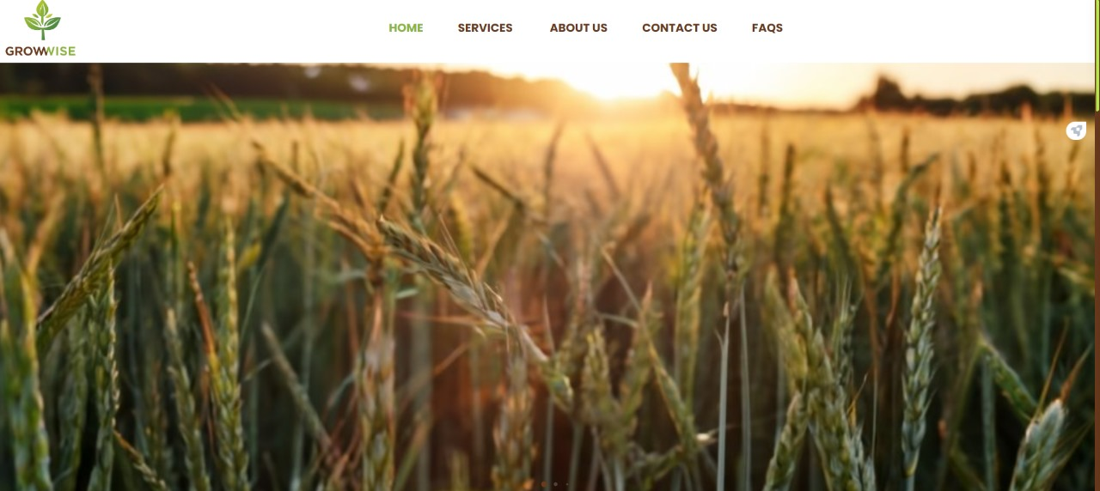
Figure 5-1: Landing Page

CROP DISEASE IDENTIFICATION PAGE
Navigating through the "Services" tab in the navigation bar reveals a dropdown menu. Users selecting "Disease Identifier" unlock a dedicated page for crop disease identification.
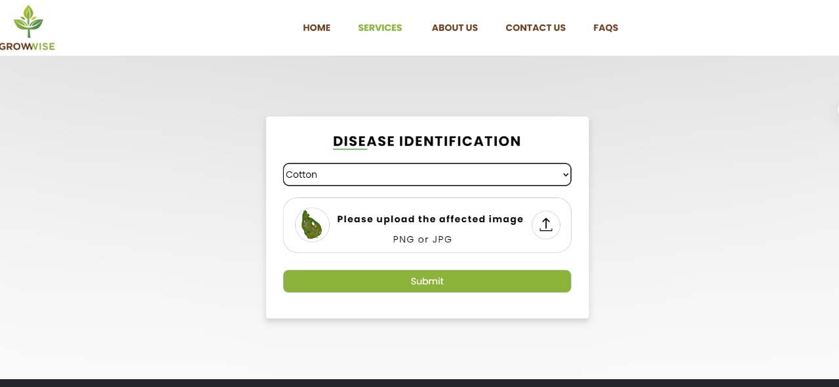
Figure 5-2: Disease identification page

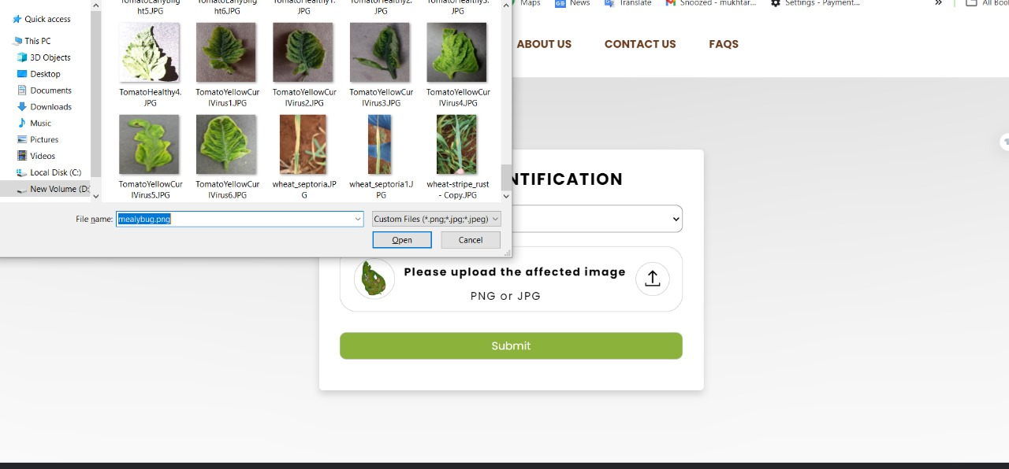
Figure 5-3: Disease identification upload image

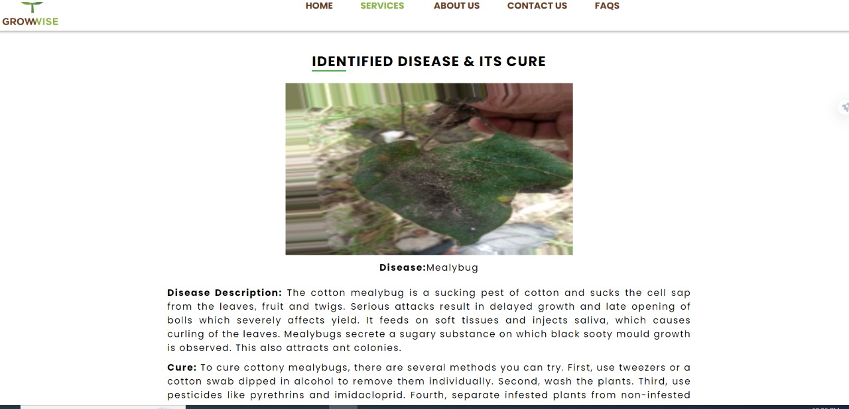
Figure 5-4: Disease identification result

Crop Recommendation page
Upon selecting "Services" from the navigation bar, users encounter a dropdown menu. Opting for "Crop Recommender" leads to a specialized page. Here, users can input soil data, receiving tailored crop recommendations. This intuitive feature streamlines decision-making for optimal agricultural outcomes.
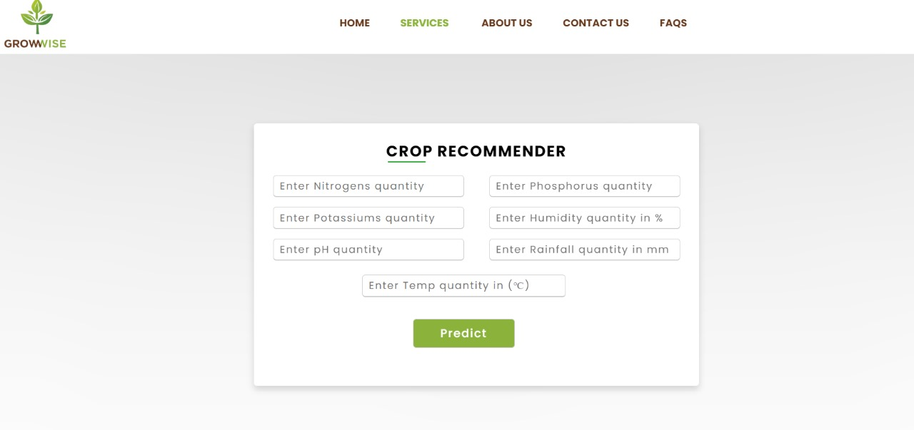
Figure 5-5: Crop recommender page

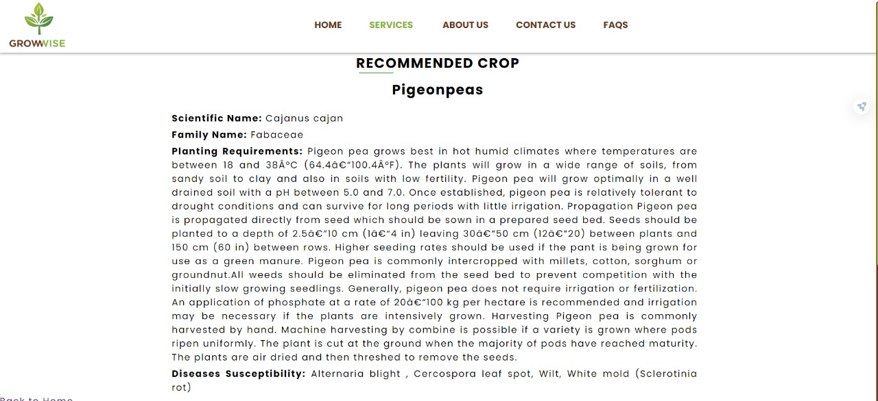
Figure 5-6: Crop recommender result

Plant information Search page:
Users seamlessly explore the landing page, where the "Services" dropdown unfolds with key options. Opting for "Plant Information Search" directs users to the page.

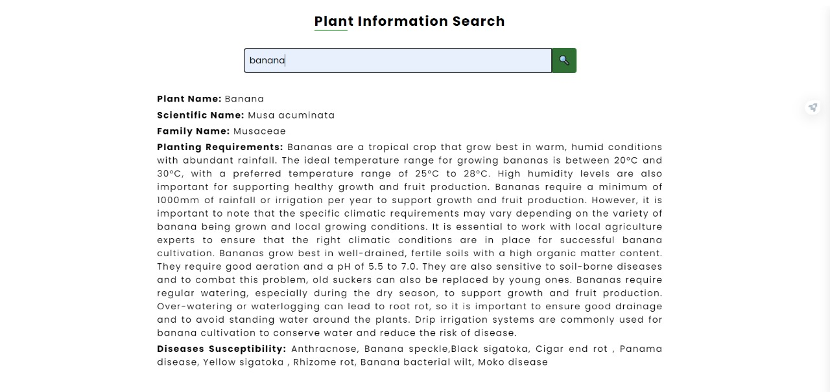
Figure 5-7: Plant information search page

Results and Conclusions

Result:
The demonstration of our web app showcased the successful integration of cutting-edge technologies to provide valuable agricultural services. The Disease Identifier efficiently identified diseases from uploaded images, aiding in timely and precise management. The Crop Recommender accurately recommended crops based on provided soil test and environmental conditions data, offering farmers a tool to optimize yield by sowing best crop on the field. The Plant Information Search function facilitated swift access to plant information. The intuitive user interface ensured a seamless experience, highlighting the project's practical application and user-centric design.
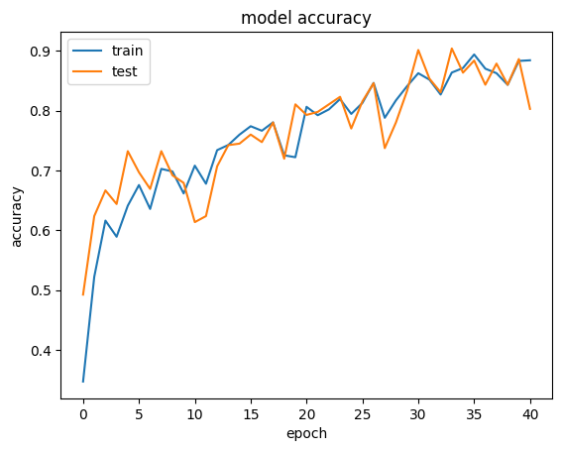
Figure 6-1: Disease identification (Cotton) accuracy

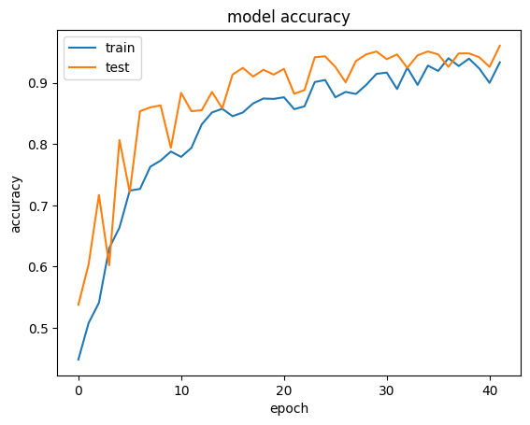
Figure 6-2: Disease identification (Banana) accuracy

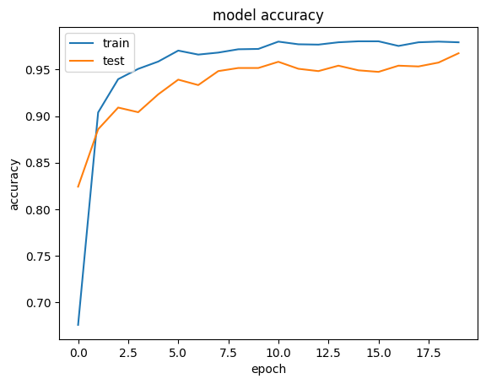
Figure 6-3: Disease identification (Mango) accuracy
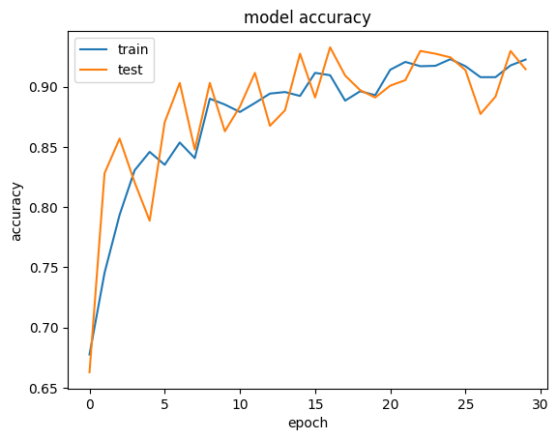
Figure 6-4: Disease identification (Wheat) accuracy

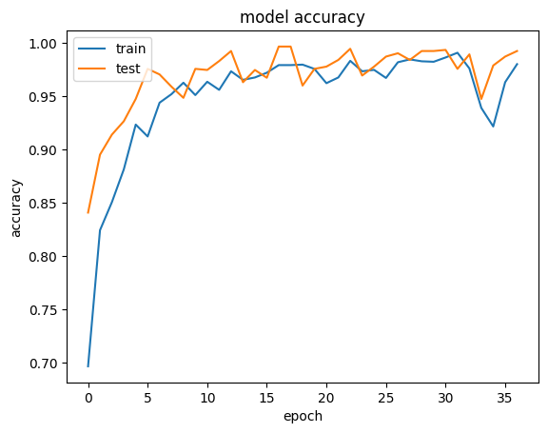
Figure 6-5: Disease identification (Pepper) accuracy
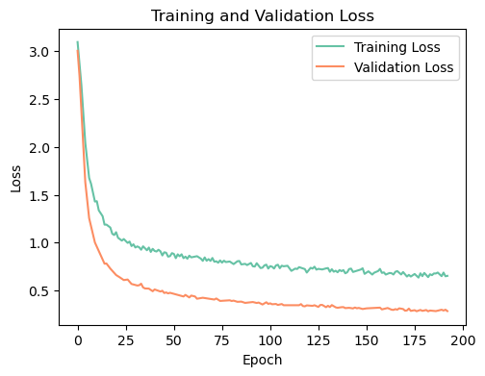
Figure 6-6: Crop recommender training and validation loss

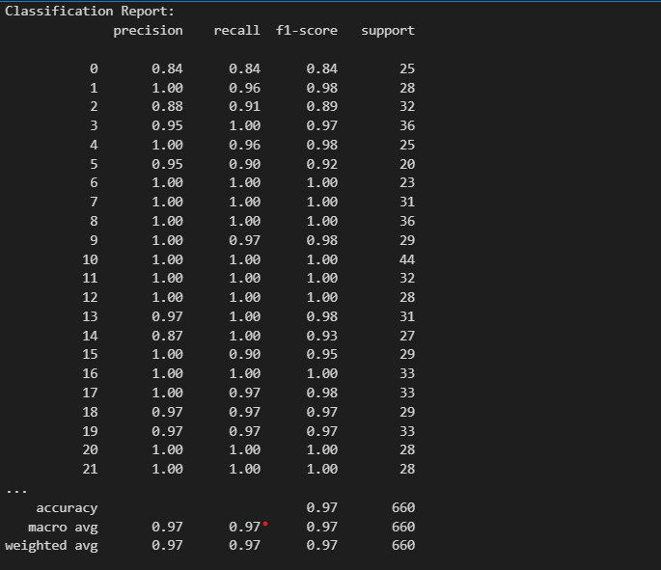
Figure 6-7: Crop recommender classification report

Conclusion:
In the dynamic realm of technological advancements, agriculture has undergone transformative changes. Our project stands as a testament to this progress, addressing identified gaps from previous endeavours to empower farmers and researchers. The website's functionalities offer a holistic solution, enabling users to accurately identify crop diseases through uploaded leaf images with an average of 92% accuracy and receive corresponding treatment recommendations. The crop recommendation system, powered by Artificial Neural Networks (ANN), enhances decision-making by predicting the optimal crop based on soil and environmental data with an accuracy of 90%. Additionally, the plant information search feature caters to users seeking fundamental details about various plants. The user-friendly interface ensures seamless navigation, contributing to the creation of an effective yet minimalist web application. By continually adapting and expanding its functionalities, our project holds immense potential to revolutionize agricultural practices and contribute to a sustainable future for the industry.

Future work:
While we have exerted our best efforts within the available time frame, the project naturally leaves room for future enhancements. The identified gaps and potential areas for improvement include:
- Developing mobile app for our project.
- Increase the number of plants covered in disease identification models. This expansion would involve acquiring additional datasets and training machine learning models to accurately identify and manage diseases across a broader spectrum of plants.
- Enhance the plant information database by adding a wider variety of plant species. This expansion aims to create a more comprehensive resource for users seeking information on diverse plants.
- Explore opportunities to introduce additional agricultural services. This could involve incorporating features that cater to specific needs within the agricultural domain, offering a more comprehensive suite of tools for users.

References:
- H, Kishan & Mishra, Dipali & D, Deepa. (2021). Automation and integration of growth monitoring in plants (with disease prediction) and crop prediction. Materials Today: Proceedings. 43.10.1016/j.matpr.2021.01.973.
- Islam, Md. M., Md A. A. Adil, Md. A. Talukder, Md. K. U. Ahamed, Md A. Uddin, Md. K. Hasan, Selina Sharmin, Md. M. Rahman, and Sumon K. Debnath. "DeepCrop: Deep Learning-based Crop Disease Prediction with Web Application." Journal of Agriculture and Food Research 14, (2023): 100764. Accessed January 25, 2024. https://doi.org/10.1016/j.jafr.2023.100764.
- Attri, Ishana, Lalit K. Awasthi, Teek P. Sharma, and Priyanka Rathee. "A Review of Deep Learning Techniques Used in Agriculture." Ecological Informatics 77, (2023): 102217. Accessed January 25, 2024. https://doi.org/10.1016/j.ecoinf.2023.102217.
- Arnal Barbedo, Jayme G. "Plant Disease Identification from Individual Lesions and Spots Using Deep Learning." Biosystems Engineering 180, (2019): 96-107. Accessed January 25, 2024. https://doi.org 10.1016/j.biosystemseng.2019.02.002.
- Bakhabar Kissan: https://bkk.ag/
- AARI Punjab: https://aari.punjab.gov.pk/
- Agri Sindh: https://agri.sindh.gov.pk/
- CropPedia - A crop encyclopedia (Last year’s project).
- Implementation model: https://www.plutora.com/blog/incremental-model-what-and-how-to-implement-it
- Functional and Non Functional Requirement: https://www.geeksforgeeks.org/functional-vs-non-functional-requirements/
- Design: https://www.includehelp.com/basics/software-design-phase-in-sdlc.aspx
- Use case: https://www.lucidchart.com/pages/uml-use-case-diagram
- Architecture Diagram: https://www.interviewbit.com/blog/system-architecture/
- Sequence diagram: https://www.visual-paradigm.com/guide/uml-unified-modeling-language/what-is-sequence-diagram/#:~:text=Sequence%20Diagrams%20are%20time%20focus,messages%20are%20sent%20and%20when.
- DFD: https://www.lucidchart.com/pages/data-flow-diagram
- ERD: https://www.lucidchart.com/pages/er-diagrams
- HTML: https://developer.mozilla.org/en-US/docs/Web/HTML
- CSS: https://developer.mozilla.org/en-US/docs/Learn/Getting_started_with_the_web/CSS_basics
- JavaScript: https://developer.mozilla.org/en-US/docs/Web/JavaScript
- Python: https://en.wikipedia.org/wiki/Python_(programming_language)
- Flask: https://pypi.org/project/Flask/
- Jinja2: https://palletsprojects.com/p/jinja/
- MySQL: https://dev.mysql.com/doc/refman/8.0/en/what-is-mysql.html
- Cotton plant disease: https://www.kaggle.com/datasets/dhamur/cotton-plant-disease
- Cotton leaf dataset: https://www.kaggle.com/datasets/ataher/cotton-leaf-disease-dataset
- New plant disease dataset: https://www.kaggle.com/datasets/vipoooool/new-plant-diseases-dataset/data
- Bangladeshi crops disease dataset: https://www.kaggle.com/datasets/nafishamoin/bangladeshi-crops-disease-dataset
- Soybean leaf data for disease identification: https://www.kaggle.com/datasets/vaishaligbhujade/soybean-leaf-dataset-for-disease-classification
- Mango leaf disease dataset: https://www.kaggle.com/datasets/aryashah2k/mango-leaf-disease-dataset
- Rice leaf dataset: https://www.kaggle.com/datasets/vbookshelf/rice-leaf-diseases
- Crop recommendation dataset: https://www.kaggle.com/datasets/atharvaingle/crop-recommendation-dataset
- Machine learning: https://www.datacamp.com/blog/what-is-machine-learning
- ANN: https://en.wikipedia.org/wiki/Artificial_neural_network
- CNN: https://towardsdatascience.com/convolutional-neural-networks-explained-9cc5188c4939

